**LA MENNAIS SCHOOLS EXAMINATIONS COMMITTEE**

**BEGINNING OF TERM III EXAMINATIONS - 2022**

**LITERACY A for p.2**

Name:___________________________________________________________________________________

School: __________________________________________________________Stream_______________

**SECTION A**

1. Write one example of a domestic bird.

______________________________________________________________

2. A_______________________ is a young plant.

3. Give one use of animals to people.

______________________________________________________________

4. Name the second stage of a housefly.

______________________________________________________________

5. Give one use of soil to people.

______________________________________________________________

6. Give one example of a non-living thing.

______________________________________________________________

7. Which immunisable disease is this child suffering from?

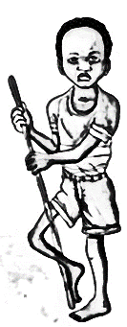

___________________________________________________

8. Give the main natural source of water.

______________________________________________________________

9. How many fingers do you have?

______________________________________________________________

10. Give one example of accidents at school.

______________________________________________________________

11. Why should we bathe with soap?

______________________________________________________________

12. Mention one example of a fruit.

______________________________________________________________

13. What do we call a person who treats our teeth?

______________________________________________________________

14. Which animal guards our home?

______________________________________________________________

15. How much main body parts does an insect have?

______________________________________________________________

16. **In the space below, draw a slasher.**

17. **Name this item used to clean the body.**

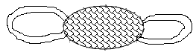

______________________________________

18. Which insect gives us honey?

______________________________________________________________

19. Name the best soil for growing crops.

______________________________________________________________

20. Who takes care of sick children at school?

______________________________________________________________

**SECTION: B**

21. a) Why is a spider not called an insect?

______________________________________________________________

b) **Match the insects to diseases they spread.**

housefly malaria

tsetsefly trachoma

mosquitoes sleeping sickness

Housefly ______________________________________________________

Tsetse fly _____________________________________________________

Mosquito _____________________________________________________

22. **Draw these things we make from animal hides and skins**.

|  |  |  |  |
| --- | --- | --- | --- |
| shoes | drum | bag | Belt |
|  |  |  |  |

23. a) Give three examples of common accidents.

i)________________________________ii) ___________________________

iii) ____________________________________________________________

b) Write one way how we can prevent accidents on the road.

______________________________________________________________

24. Which part of the body do we use for;

a) breathing __________________________________________________

b) picking a plate _____________________________________________

c) kicking a ball _______________________________________________

d) reading ____________________________________________________

25. **Draw these things we find in the first aid box**.

|  |  |  |  |
| --- | --- | --- | --- |
| Scissors | Cotton wool | Gloves | Bandage |
|  |  |  |  |

26. a) **Name the parts of a plant.**

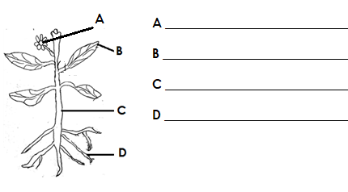

b) Give the importance of the part labelled d.

______________________________________________________________

27. a) What do we call the general cleanliness of a place?

______________________________________________________________

b) Write three places we need to keep clean.

______________________________________________________________

28. a) Give any three examples of body exercises you know.

i) ____________________________________________________________

ii) ____________________________________________________________

iii) ____________________________________________________________

b) Why is it good to do body exercises?

______________________________________________________________

29. Name the meat of the following animals

cow _______________________ pig ______________________

fish_________________________ sheep ______________________

30. a) Why do people boil drinking water?

______________________________________________________________

b) Give three sources of water.

i) ______________________________ ii) ____________________________

iii) ____________________________________________________________

31. a) Give two methods of preserving food.

i)_____________________________________________________________

ii) ____________________________________________________________

b) Mention two examples of food preserved by sun drying.

(i)______________________________(ii) ____________________________

32. a) ___________________________is a meal that contains a balanced diet.

b) Give the classes of food which make a balanced diet.

i) _____________________________________________________________

ii) ____________________________________________________________

iii) ___________________________________________________________

33. a) What are harmful insects?

____________________________________________________________________________________________________________________________

b) Give three examples of harmful insects.

i) *______________________________ ii) ____________________________*

iii) ____________________________________________________________

34. a) What are domestic birds?

____________________________________________________________________________________________________________________________

b) Give three things we get from keeping birds at home.

i) _____________________________________________________________

ii) ____________________________________________________________

iii) ___________________________________________________________

35. **Match animals with their weapons.**

a) chameleon stings

b) cat smells

c) bedbug claws

d) bee changes colour

a) chameleon _____________________________________________

b) cat _____________________________________________

c) bedbug _____________________________________________

d) bee ______________________________________________

**END**